Updates from our YAA Alumni ……
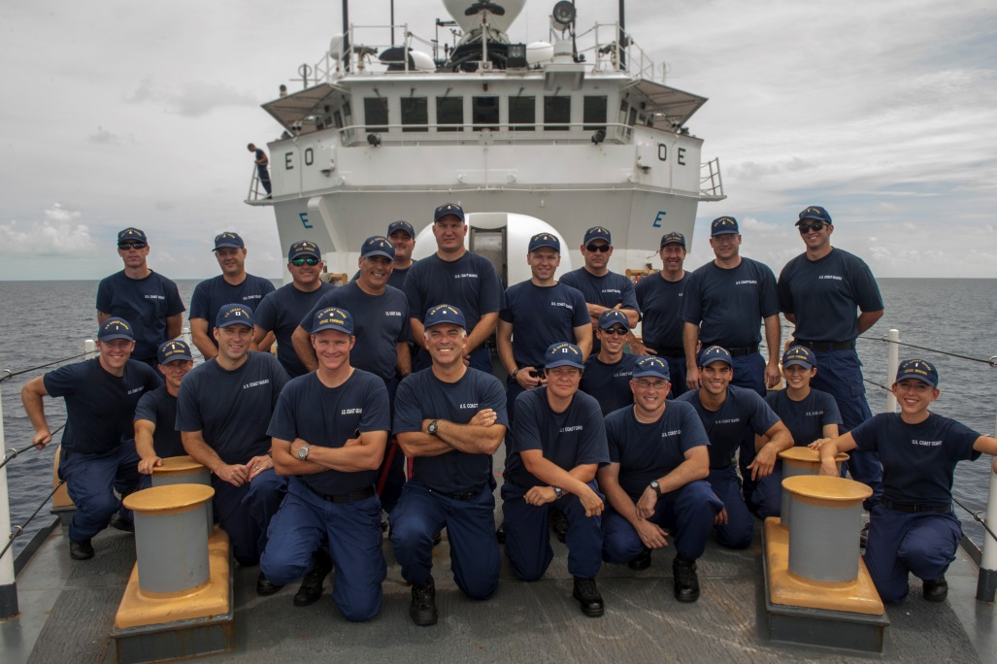
Ensign Lydia Monks USCG (first row, far right) onboard the USCGC Forward engaged in migrant and drug trafficking interdiction. Lydia is home based in Key West, FL and is a ’09 Awardee.
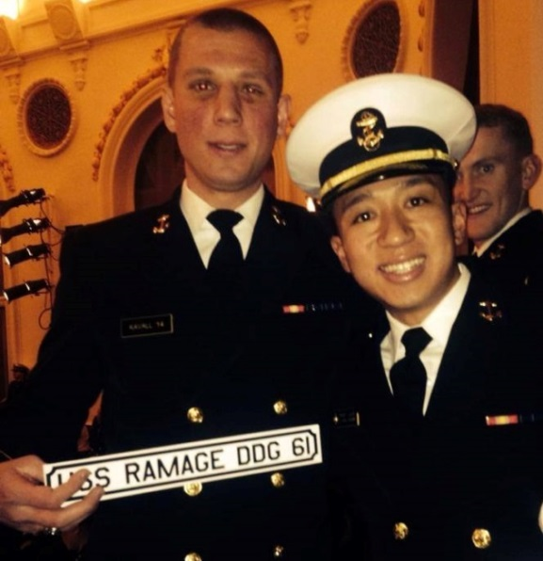
Midshipman Alex Kavall 1/C, United States Naval Academy receives his 2014 Ensign assignment as an officer onboard the USS Ramage, a guided missile destroyer home-based in Norfolk, VA. Alex, a ’10 Awardee, recently broke his nose in a boxing competition and hopes he’ll look better for his May graduation! He plans to receive a BS in Systems Engineering and a minor in Russian.
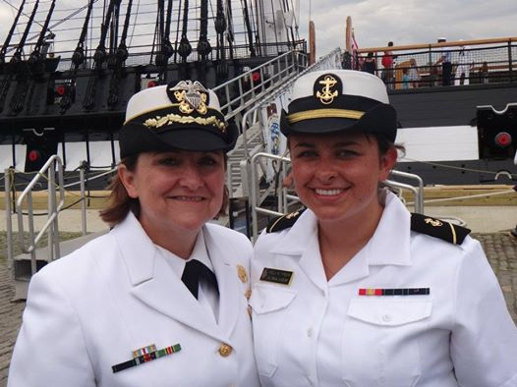
Midshipman Kelli Freer 2/C United States Naval Academy pictured with her mom and WCMOA member CAPT Dori Freer. Kelli is a ’12 Awardee and top scholarship recipient.
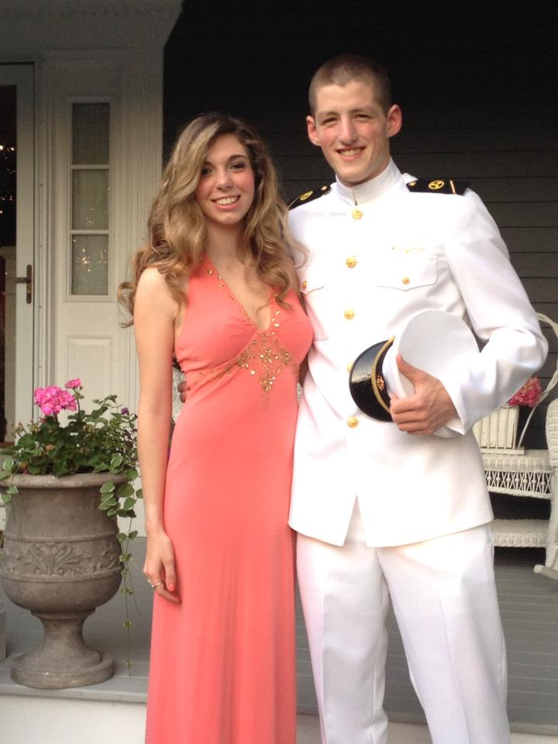
Midshipman Timothy Cottell 3/C, United States Merchant Marine Academy on his way to the June Ball 2013 at the academy. Tim is now sailing on merchant ships in pursuit of his license as a third assistant engineer. Tim is a YAA ’11 awardee.
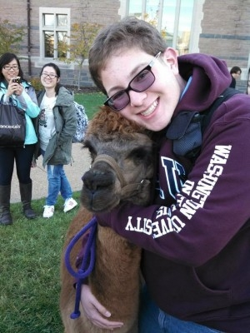
David Gumins, YAA ’13, a freshman at Washington University, was recently featured in his school’s newspaper. Please click here to read about this amazing awardee. http://www.facebook.com/l.php?u=http%3A%2F%2Fwww.studlife.com%2Fscene%2Fprofile%2F2014%2F02%2F20%2Fall-roads-lead-to-david-gumins-how-one-freshman-seems-to-know-everyone-by-name-and-story%2F&h=LAQHMooQa
Should anyone have any news about our awardees, please submit a short article for inclusion in our newsletter.

